P1 Manual
App Name: Stock Room Tracker Mentor: Kayla Wilson

Team Members: Christopher Levesque

Project Description:

Target audience:
The target audience will be hospitals and the users will be the nurses.

Target device: iPhone

One paragraph summary of what your app will do:

The app will help keep track of inventory for the nursing stock room. A nurse will be able Log in to the app while on their shift and use the app to associate items of the stock room to their patient when they use it. To check out an item a nurse will go into the stock room and select the item the patient needs. They will then in the app select the patient, be brought to a check out screen either scan or search the item, input a quantity, and then check out the item. The items and price of items will then be associated to the patient and added to their bill for their stay.

Benefits:

This app will help the nurses keep better track or the items in the stock room. It will eliminate lost money for items that go unchecked out and are never paid for on a patient’s bill. It will be a quicker system than the nurses already have, which is a desktop computer the nurse actually has to sit down at and check out the items. This makes it easier for the nurses who are always active and do not have much time to sit down on a computer to fill out the paper work.

Brief description of any artifacts (if any) residing on the device

N/A

List additional devices required by app (sensors, etc.)

N/A

Final Schema of local database:

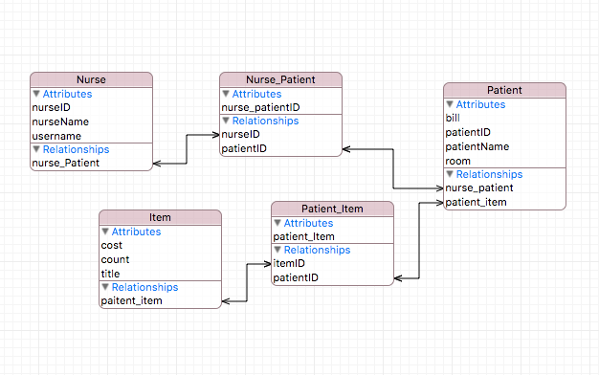
The local database will be similar to the external database but it will on hold the password of the nurse for security reasons. The username and name will really just be used to populate text fields in the App. All other information will be used to save a patient table and item table in the application.

Schema of external database:

External Database will have Users that link to nurse information. It will have a Patients table where their information will be kept (Name, Bill, What room they are in, anything else the nurse may need to know). There will also be an items database that keeps their name, cost and possible a barcode or something that is used to quickly search the item. This database will have to be on a server accessed through the web. This database will then work in with the hospitals existing

Nurse
nurseID: INT, PRIMARY KEY
username: VARCHAR
password: VARCHAR
name: VARCHAR
Nurse_Patient
nurse_patientID: INT, PRIMARY KEY
patientID: INT, FOREIGN KEY
nurseID: INT, FOREIGN KEY

Patient
patient_id: INT, PRIMARY KEY
patientName: VARCHAR
Room: INT
Bill: DOUBLE
Item_Patient
item_patientID: INT, PRIMARY KEY
patient_id: INT, FOREIGN KEY
item_patientID: INT, FOREIGN KEY

Item
itemID: INT, PRIMARY KEY
title: VARCHAR
cost: DOUBLE
count: DOUBLE

Authoring Tool Functionality (What the app will publish to the external database):

The app should be able to create a new user account (Nurse account). The app will update the bill of a patient in the external database. It will also update the count of each item in the external database. It should also be able to update information in the nurse’s account.

Web Tool Functionality (What data will the users be able to see?):

Users should be able to view the patient database that includes the cost of the items they have used. They can also view the list of item and the quantity left.

Story Board Sketch (use separate pages):

